**Sensor Field Verification Procedure**

**Well Name**

**FINAL**

**Rev. 0**

**Section XXXX**

**XX County, State**

**Prepared By:**

**XX**

**Data Engineer**

**Reviewed By:**

**XX**

**Drilling Engineer**

**Approved By:**

**___________________________________**

**XX**

**Drilling Engineering Supervisor**

**___________________________________**

**XX**

**Drilling Manager**

**___________________________________**

**XX**

**Drilling Superintendent**

Table of Contents

1. Contacts 4

2. Sensor Field Verification Procedures – Purpose 5

3. Pre-checks 5

4. Procedure - Top Drive Verification 6

4.1. Torque (Top Drive) 6

4.2. RPM (Top Drive) 7

5. Procedure - Mud Pump Verification 8

5.1. SPM (Mud Pumps) 8

6. Procedure – Block Position Verification 9

6.1. Absolute Position (Blocks) 9

6.2. Encoder Check (Blocks) 10

7. Procedure – Pressure Verification 11

7.1. Pressure 11

8. Appendix 1 – Pre-checks 12

9. Appendix 2 – Top Drive Torque Verification – Table to Record Readings 13

10. Appendix 3 – Top Drive RPM Verification – Table to Record Readings 14

11. Appendix 4 – Mud Pump Verification – Table to Record Readings 15

12. Appendix 5 – Block Position Verification – Table to Record Readings 16

13. Appendix 6 – Pressure Verification – Table to Record Readings 17

# Contacts

|  |  |  |  |  |
| --- | --- | --- | --- | --- |
| **Contacts** | **Drilling Manager** |  | Office:  Cell: |  |
| **Drilling Superintendent** |  | Office:  Cell: |  |
|  | Office:  Cell: |  |
| **Field Drilling Superintendent** |  | Office:  Cell: |  |
|  | Office:  Cell: |  |
|  |  | Office:  Cell: |  |
| **Drilling Engineering Supervisor** |  | Office:  Cell: |  |
|  | Office:  Cell: |  |
| **Drilling Engineer** |  | Office:  Cell: |  |
|  | Office:  Cell: |  |
| **Data Engineer** |  | Office:  Cell: |  |
|  |  | Office:  Cell: |  |
|  |  | Cell: |  |

# Sensor Field Verification Procedures – Purpose

This sensor field verification procedure is meant as a supplemental procedure to the XX Drilling procedure (Well Name/ Rig/ XX County, State).

The critical sensors on the drilling rig provide a picture of how the rig and the well are acting so we can take the appropriate measures to manage well control and operations. Using sensors that are out of our accuracy requirements may lead to inaccurate assessments of and actions to well control and operations.

The purpose of these procedures is to:

* Verify whether our critical sensors on the drilling rig are measuring within our required accuracy;
* Be aware of critical sensors that are out of the required accuracy so that appropriate remedial actions can be planned.

The timing to perform these procedures:

* Pre-checks can be done concurrently during move-in and rig-up activities.
* All verification tests (except for pressure) can be done after installation/testing of the torque tension sub on the top drive.
* Pressure verification tests will be conducted a week after spud when BOP testing is conducted.

# Pre-checks

The following are additional inspection items that the Third Party Inspector will be assisting with that may affect sensor accuracy.

1. Electrical Checks
   * Check that all cables that are part of the instrumentation/data aggregation system are free of frays, scars, cuts, kinks, or other damage.
   * Check that all junction boxes are free of damage and in proper working order. Check that diaphragms and seals are in place to prevent water intrusion.
   * Check that the rig is grounded with a copper grounding rod driven no less than 8 feet into the earth.
   * Check that all VFD, SCR, Generator, Pump, or other electrically connected skids are bonded together using metal to metal connections which are free of rust or other electrical insulation.
2. Review calibration certificates/logs for:
   * Top Drive (Rig Contractor)
   * Load cell (Rig Contractor)
   * Torque/tension sub (vendor)
   * Pressure devices (Rig Contractor)
   * Tanks/Pits (Rig Contractor)
3. Use table in APPENDIX 1 to record results.

# Procedure - Top Drive Verification

## Torque (Top Drive)

1. Personnel required for the job:
   * Company Man
   * Driller
   * Torque tension sub technician
   * Third Party Inspector
2. Test equipment required for the job (and company responsible for providing):
   * Tongs/Chains (Rig Contractor)
   * 8” Drill Collar (Rig Contractor)
   * Load Cell (Rig Contractor)
   * Tape Measure (Rig Contractor)
   * Protractor (Rig Contractor)
   * Torque/tension sub (Vendor)
3. Turn OFF the auto-driller.
4. Run the top drive at typical operating RPM for at least 10 minutes to ensure that the device is operating at a steady state condition. Torque reported from the top drive can be significantly affected by cold lubricants or gear mesh interactions from the rig move.
5. Make up 8” drill collar to top drive. (Use crossover if necessary).
6. Affix tongs to 8” drill collar (that is made up to the top drive). Ensure tongs are level with the plane of the rig floor.
7. Affix approved tension device (i.e., chains) with a calibrated in-line tension gage (load cell) to a member of the rig that is approved for torque testing. Ensure that the approved tension device is within 90 degrees +/- 5 degrees in respect to the tongs.
8. Measure the distance from the center of the 8” drill collar to the chains. This is the moment arm. Record the number in decimal feet.
9. 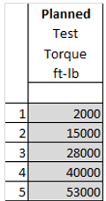Test from 2000 to 53000 ft-lb (4 torque increments).   
   Each test torque will be conducted 4 times. (torque, release … 4 times).   
   Torque test plan is listed in the table to the right.  
     
   Use the table in APPENDIX 2 to record the readings for:
   * Top Drive Torque (ft-lb)
   * Load Cell Force (lb)

Calculated Load Cell Torque (ft-lb) = Load Cell Force (lb) x Moment Arm (ft)

* + NOV Torque (ft-lb)

1. Results:
   * Error should be less than 5% between:
     1. Calculated Load Cell Torque and Top Drive Torque
     2. Calculated Load Cell Torque and NOV Torque
   * If error is greater than 5%, contact Rig Contractor (Top Drive Torque) or Vendor (for torque tension sub-torque) for service and consult with Superintendent and Drilling Engineer. (Drilling operations can generally continue while awaiting the service tech. Torque values can be adjusted with calculated error.)

## RPM (Top Drive)

1. Personnel required for the job:
   * Company Man
   * Driller
   * Torque tension sub technician
   * Third Party Inspector
2. Test equipment required for the job (and company responsible for providing):
   * Marking device (Rig Contractor)
   * Timer (Third Party Inspector)
   * Torque/tension sub (Vendor)
   * Recording device (Rig Contractor)
3. Make a chalk, grease pencil, or other mark on the quill or saver sub on the Top Drive.
4. Set a one-minute timer and request the top drive to rotate at test speeds (30, 60, 90, 120 RPM).
5. Count the number of revolutions in one minute.
   * At 120 RPM, it may be difficult to count. It may be necessary to use a recording device such as a cellular phone camera with slow motion video capture. Prior to spud, the rig floor has no NFPA hazardous or combustible materials classification, and electrical equipment may be used without permitting. If required, LEL (lower explosive limit) can be checked and continuously monitored.
6. Use the table in APPENDIX 3:
   * Top Drive RPM reading
   * NOV RPM reading
   * Counts of revolutions per minute
7. Results:
   * Acceptable error is +/- 2 RPM between:
     1. Counts of revolutions per minute and Top Drive RPM reading
     2. Counts of revolutions per minute and Torque Tension Sub RPM reading
   * If error is greater than acceptable error, contact Rig Contractor (top drive RPM) or Vendor (for Torque Tension Sub RPM) for service and consult with Superintendent and Drilling Engineer. (Drilling operations can generally continue while awaiting the service tech. RPM values can be adjusted with calculated deviation.)

# Procedure - Mud Pump Verification

## SPM (Mud Pumps)

1. Personnel required for the job:
   * Company Man
   * Driller
   * Third Party Inspector
2. Test equipment required for the job (and company responsible for providing):
   * Timer (Third Party Inspector)
3. Set a one-minute timer and request the pump to be set at the appropriate SPM.   
   Test to be conducted at 30, 60, 90 SPM.
4. Count the number of strokes in one minute.
   * Use the table in APPENDIX 4 to record the readings.
5. Results:
   * Acceptable error is +/- 2 SPM from set point.
   * If error is greater than acceptable error, contact Rig Contractor for service and consult with Superintendent and Drilling Engineer. (Drilling operations can generally continue while awaiting the service tech. SPM values can be adjusted with calculated deviation.)

# Procedure – Block Position Verification

## Absolute Position (Blocks)

1. Personnel required for the job:
   * Company Man
   * Driller
   * Third Party Inspector
2. Test equipment required for the job (and company responsible for providing):
   * Timer (Third Party Inspector)
3. Choose a random height at which to position the top drive in the derrick. Measure from a standardized location chosen by the rig such as the bottom of the elevators or pipe handler.
4. Use an approved measurement device to measure the actual height in the derrick and record the set-point and observed position.
5. Repeat Steps 4 and 5 using no fewer than 3 points, preferably dividing the derrick into thirds (at each new wrap of the drum).
6. Use the table in APPENDIX 5 to record the readings.
7. Results:
   * Acceptable error is < 0.1 ft.
   * If error is greater than acceptable error, contact Rig Contractor for service and consult with Superintendent and Drilling Engineer.

## Encoder Check (Blocks)

1. Personnel required for the job:
   * Company Man
   * Driller
   * Third Party Inspector
2. Test equipment required for the job (and company responsible for providing):
   * Timer (Third Party Inspector)
3. Align a static part of the top drive or traveling block (i.e., bottom of the bails, quill, bottom of the sheaves) with the top of the measuring device. Record for use in step 6.
4. Record reading on electronic data recorder (before reading for the encoder).
5. Move the top drive up and down the derrick until at least 1000 ft of travel has been achieved (typically 5 times up and 5 times down).
6. Return the system to its original position with respect to the measurement device.
7. Record the block position reported by the electronic data recorder (after reading for the encoder).
   * Use the table in APPENDIX 5 to record the readings.
8. Results:
   * Acceptable error:   
     The absolute value final reported block position (displacement) should be less than 0.5% of the total distance traveled.
   * If error is greater than acceptable error, contact Rig Contractor for service and consult with Superintendent and Drilling Engineer.

# Procedure – Pressure Verification

## Pressure

1. Personnel required for the job:
   1. Company Man
   2. BOP tester
2. Test equipment required for the job (and company responsible for providing):
   1. Pressure testing equipment (BOP Tester)
   2. Necessary connections (BOP Tester)
3. All pressure sensors to be verified by BOP tester(s), in conjunction with BOP testing.
4. The following minimum set of gages should be tested every rig-up:
   * Choke Panel Gage
   * Choke Manifold Gage
   * Casing (annular) Gage
   * Any other gage(s) material to well control operations
5. The following gages are to be verified at the same time:
   * ALL rig-owned gauges and any other gauge(s) connected to the stand pipe and providing data to remote viewers or other users should be tested and recorded as well.
6. After the BOP test, tie test into the circulating system and prepare a fresh chart.
7. Test circulating system and all gauges to 50% and 100% of maximum expected working pressure (or as advised by on-site representative). Pressure should be held for 10 minutes or until transients no longer influence the pressure reading, whichever is longer. Pressure should be static over the duration of the test.
8. Use the table in APPENDIX 6 to record the readings.
9. Results:
   1. Acceptable error:   
      Minimum accuracy of 1% of full scale or 100 psi, whichever is less.
   2. If error is greater than acceptable error, contact Rig Contractor for service and consult with Superintendent and Drilling Engineer.

# Appendix 1 – Pre-checks



# Appendix 2 – Top Drive Torque Verification – Table to Record Readings

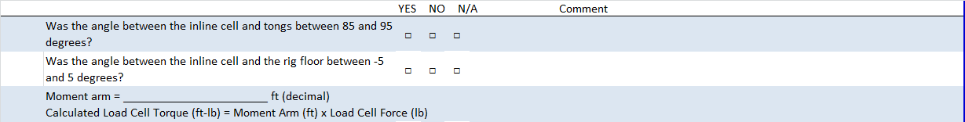



# Appendix 3 – Top Drive RPM Verification – Table to Record Readings

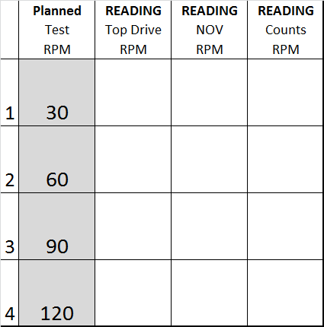

* + Acceptable error is +/- 2 RPM between:
    1. Counts of revolutions per minute and Top Drive RPM reading
    2. Counts of revolutions per minute and Torque Tension Sub RPM reading

# Appendix 4 – Mud Pump Verification – Table to Record Readings



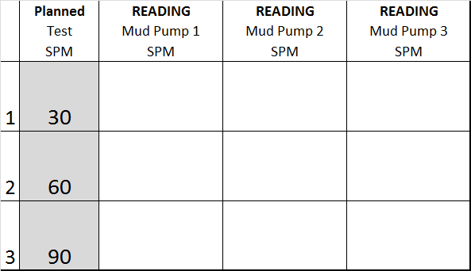

* + Acceptable error is +/- 2 SPM from set point.

# Appendix 5 – Block Position Verification – Table to Record Readings



Absolute Position Check

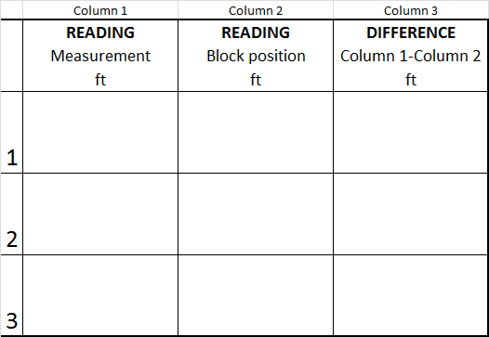

Encoder Check



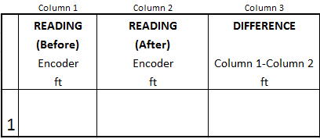

# Appendix 6 – Pressure Verification – Table to Record Readings



Required minimum accuracy of 1% of full scale or 100 psi, whichever is less.